**BIHAR ENGINEERING UNIVERSITY, PATNA**

A MAJOR PROJECT REPORT

on

# ELECTRICAL POWER GENERATION USING SPEED BREAKER

Submitted in partial fulfilment of the requirements for the award of

**BACHELOR OF TECHNOLOGY**

**In**

**MECHANICAL ENGINEERING**

For the academic session 2019-2023 Submitted by

|  |  |
| --- | --- |
| **SONU KUMAR PASWAN** | **(19102125003)** |
| **RAMNARAYAN MANDAL** | **(19102125013)** |
| **BHUSHAN KUMAR** | **(19102125014)** |
| **AVINAV RAJ** | **(19102125016)** |
| **SHANKAR KUMAR YADAV** | **(19102125053)** |

Under the guidance of

**Mr. Rahul Kumar**

**Asst. Professor Dept. Of Mechanical Engineering, RRSDCE**



**2019-2023**

**Department Of MECHANICAL ENGINEERING**

Rashtrakavi Ramdhari Singh Dinkar College of Engineering, Begusarai

***CERTIFICATE***

The minor project report entitled "“ELECTRICAL POWER GENERATION USING SPEED BREAKER" prepared by Shankar Kumar Yadav (19102125053), Sonu Kumar Paswan (19102125003), Ramnarayan Mandal (19102125013), Bhushan Kumar (19102125014], Avinav Raj (19102125016) , Department of Mechanical Engineering, RRSDCE Begusarai is hereby approved and certified as a creditable study in the technical subject carried out and present in a satisfactory manner to warrant its acceptable as pre-requisite to the degree for which it has been submitted.

Signature of Guide Signature of HOD

Mr. Rahul Kumar

Asst. Professor

Dept. of mechanical engineer RRSDCE, Begusarai.

Mr. Abhishek Kumar

Head of the Department,

Dept. of mechanical engineer RRSDCE, Begusarai

**External Viva**

Name of Examiners Signature & date

**DECLERATION**

I declare that this project report titled “ **ELECTRICAL POWER GENERATION USING SPEED BREAKER** ” submitted in partial fulfillment of the degree of B.Tech in (Mechanical Engineering) is a record of original work carried out by Shankar Kumar Yadav (19102125053), Sonu Kumar Paswan (19102125003), Ramnarayan Mandal (19102125013), Bhushan Kumar (19102125014), Avinav Raj (19102125016) under the supervision of Prof. Rahul Kumar and has not formed the basis for the award of any other degree or diploma, in this In keeping with the ethical practice in reporting scientific information, due acknowledgements have been made wherever the findings of others have been cited.

Place: Begusarai

Date: / /

**Name Signature**

Shankar Kumar Yadav (19102125053) Sonu Kumar Paswan (19102125003) Ramnarayan Mandal (19102125013)

Bhushan Kumar (19102125014)

Avinav Raj (19102125016)

ABSTRACT

Energy is the most fundamental requirement for the continued existence of any living thing in the cosmos. Everything that occurs in the world is a manifestation of energy flowing in some manner. However, conventional energy sources are decreasing and the global population is steadily growing. The over consumption of energy has led to insufficient energy supply during the next five years. In order to solve this issue, we must adopt practices that maximize the use of energy from traditional sources. In my work, I explain how to harness the energy released as a car bounces over a speed bump. When a car drives over it, it releases a great deal of kinetic energy. A speed breaker can double as a generator to harness the kinetic energy it creates and supply electricity to the grid. A rack and pinion system can transfer the kinetic energy of a moving vehicle into the mechanical energy of the shaft. Next, a generator will transform the mechanical energy into electricity, which will be stored in a battery. The money we save on electricity during the day can be put to better use at night when we turn on the street lights. As a result, this setup will help us conserve a significant amount of energy that may be put toward meeting future needs. Energy is a nonrenewable resource; yet, it is possible to transform one form of energy into another. The law of energy conservation is something all of us study. Energy comes from a variety of nuclear, hydro, thermal, and other sources. However, the project is moving forward in several places, particularly on the roadways.

**ACKNOWLEDGEMENT**

The satisfaction and euphoria that accompany the successful completion of any task would be incomplete without the mentioning of the people whose constant guidance and encouragement made it possible. We take pleasure in presenting before you, our project, which is result of studied blend of both research and knowledge.

We express our earnest gratitude to our guide, Asst. Professor Mr. Rahul Kumar, our project guide, for his constant support, encouragement, and guidance. We are grateful for his cooperation and his valuable suggestions. Finally, we express our gratitude to all other members who are involved either directly or indirectly for the completion of this project.

Finally, we thanks all of our family for their understanding love and support.

Shankar Kumar Yadav (19102125053) Sonu Kumar Paswan (19102125003) Ramnarayan Mandal (19102125013)

Bhushan Kumar (19102125014)

Avinav Raj (19102125016)













 

















 









**CHAPTER 1**

# INTRODUCTION

An energy crisis is any great bottleneck (or price rise) in the supply of energy resources to an economy. An energy crisis may be referred to as an oil crisis, petroleum crisis, energy shortage, electricity shortage electricity crisis. This project is about generation of electricity with the speed breakers. In daily life a lot of energy is lost like the potential energy of vehicles. In this project we are just trying to make use of such energy in order to generate an electrical energy. This project will work on the principle of “potential energy to electrical energy conversion”. Potential energy can be thought of as energy stored within a physical system. This energy can be released or converted into other forms of energy, including kinetic energy and further used to charge a battery and used when needed.

In the present scenario power becomes the major need for human life. The availability and its precipitate consumptions are regarded as the index of national standard of living in the present day civilization. Energy is an important input in all the sectors of any countries economy. Energy crisis is due to two reasons, firstly the population of the world has been increased rapidly and secondly standard of living of human being has increased. India is the country, which majorly suffers with lack of sufficient power generation. As per India is only 150 kWh with 7% of world population consumes 32% of total power generation where as India as developing country with 20% of world population consumes only 1% of total energy consumed in the world. The availability of regular conventional fossil fuels will be the main sources for power generation, but there is a fear that they will get exhausted eventually by the next few decades. Therefore, we have to investigate some approximate, alternative, new sources for the power generation, which is not depleted by the very few years.

Another major problem, which is becoming the exiting topic for today is the pollution. It suffers all the living organisms of all kinds as on the land, in aqua and in air. Power stations and automobiles are the major pollution producing places. Therefore, we have to investigate other types of renewable sources, which produce electricity without using any commercial fossil fuels, which is not producing any harmful products. There are already existing such systems using renewable energy such as solar wind, OTEC (ocean thermal energy conversions) etc... For power generation. The latest technology which is used to generate the power by such renewable energy is the “POWER HUMP”

## 1.1 Energy utilization

Man in his lifetime, uses energy in one form or the other. In fact whatever happens in nature, results, out of the conversion of energy in one form or the other? The blowing of the wind, the formation of the clouds and the flow of water are a few examples that stand testimony to this fact.

The extensive usage of energy has resulted in an energy crisis, and there is a need to develop methods of optimal utilization, which will not only ease the crisis but also preserve the environment.

This project attempts to show how man has been utilizing energy and to explore prospects of optimizing the same. Researches show that the world has already had its enough shares of its energy resources. Fossil fuels pollute the environment. Nuclear energy requires careful handling of both raw as well as waste material. The focus now is shifting more and more towards the renewable sources of energy, which are essentially, nonpolluting. Energy conservation is the cheapest new source of energy. This project attempts to show how energy can be tapped and used at a commonly used system, the road speed breakers.

The number of vehicles passing over the speed breaker in roads is increasing day by day. There is possibility of tapping the energy and generating power by making the speed breaker as a power generation unit. The generated power can be used for the lamps near the speed breakers and this will be a great boon for the rural villages too. My project explains clearly, the working principle of the designed system, its practical implementation, and its advantages. Design of each component has been carried out using standard procedures, and the components have been fabricated and assembled. Practical testing of the system has been done with different loads at different speeds. Taking the various criteria that determine the power generation, graphs have been plotted. The utilization of energy is an indication the growth of a nation. One might conclude that to be materially rich and prosperous, a human being needs to consume more and more energy. And this project is best source of energy that we get in day-to-day life.

This project attempts to show how energy can be tapped and used at a commonly used system like the speed breaker in roads. The number of vehicles passing over the speed breaker in roads is increasing day by day. A large amount of energy is wasted at the speed breakers through the dissipation of heat and also through friction, every time a vehicle passes over it. There is great possibility of tapping this energy and generating power by making the speed-breaker as a power generation unit. The generated power can be used for the lamps, near the speed breakers.

## Scope of the project

The utilization of energy is an indication of the growth of a nation. For example, the per capita energy consumption in USA is 9000 kWh (kilo Watt hour) per year, whereas the consumption in India is 1200 kWh. One might conclude that to be materially rich and prosperous, a human being needs to consume more and more energy. A recent survey on the energy consumption in India had published a pathetic report that 85,000 villages. In India do not still have electricity. Supply of power in most part of the country is poor. Hence more research and development and commercialization of technologies are needed in this field. India, unlike the top developed countries has very poor roads. Talking about a particular road itself includes several speed breakers. By just placing a unit like the “power Generation Unit from Speed Breakers”, so much of energy can be tapped. This energy can be used for the lights on the either side of the roads and thus much power that is consumed by these lights can be utilized to send power to these villages**.**

## Engineering Research

Next time on the roads, don’t scoff at the speed breakers. They could light up small villages off the highway. The rotor (rotating shaft) is directly connected to the prime mover and rotates as the prime mover turns. The rotor contains a magnet that, when turned, produces a moving or rotating magnetic field. The rotor is surrounded by a stationary casing called the stator, which contains the wound copper coils or windings. When the moving magnetic field passes by these windings, electricity is produced in them. By controlling the speed at which the rotor is turned, a steady flow of electricity is produced in the winding. These windings are connected to the electricity network via transmission lines. IIT Guwahati has evaluated the machine and recommended it to the Assam ministry of power for large scale funding. IIT Design department says it is a ‘very viable proposition’ to harness thousands of megawatts of electricity untapped across the country every day. A vehicle weighing 1000 kg going up a height of 10cm on such a rumble strip produces approximately 0.98-kilowatt power. So, one such speed-breaker on a busy highway, where about 100 vehicles pass every minute, about one kilo watt of electricity can be produced every single minute. The figure will be huge at the end of the day.

A storage module like an inverter will have to be fitted to each such rumble strip to store this electricity. The cost of electricity generation and storage per megawatt from speed-breakers will be nearly Rs 1 crore as opposed to about Rs 8 crore in thermal or hydro power stations. The speed breaker on a busy road will be lifted to some height from one side and fixed to the road from other side. Then there will be a shock absorber kind of mechanism beneath the speed breaker. The arrangement will be as in a cam and shaft arrangement.

The shaft of the generator placed below will be attached to the cam and the rod connected to the speed breaker vertically will be on cam. This arrangement will make one rotation of generator shaft as soon as a vehicle moves over speed breaker. The rotations can also be increased using certain mechanisms, like gears and all. Then there will be a circuit storing the electricity generated during day time and the power generated will be used during night.

According to concept it is known as “reciprocating bump”. The speed breaker designed is supported on springs. When a vehicle mounts the speed breaker, the load on the springs causes movement which is converted to a rotary motion by using a roller chain mechanism. The energy is generated and can be stored in batteries. The input for producing energy is the weight of the vehicle producing electricity from a speed breaker is a new concept that is undergoing research. The number of vehicles on road is increasing rapidly and if we convert some of the kinetic energy of these vehicle into the rotational motion of roller then we can produce considerable amount of electricity. This is the main concept. In this project, a roller is fitted in between a speed breaker and some kind of a grip is provided on the speed breaker so that when a vehicle passes over speed breaker it rotates the roller. This movement of roller is used to rotate the shaft of DC generator by the help of chain drive which is there to provide

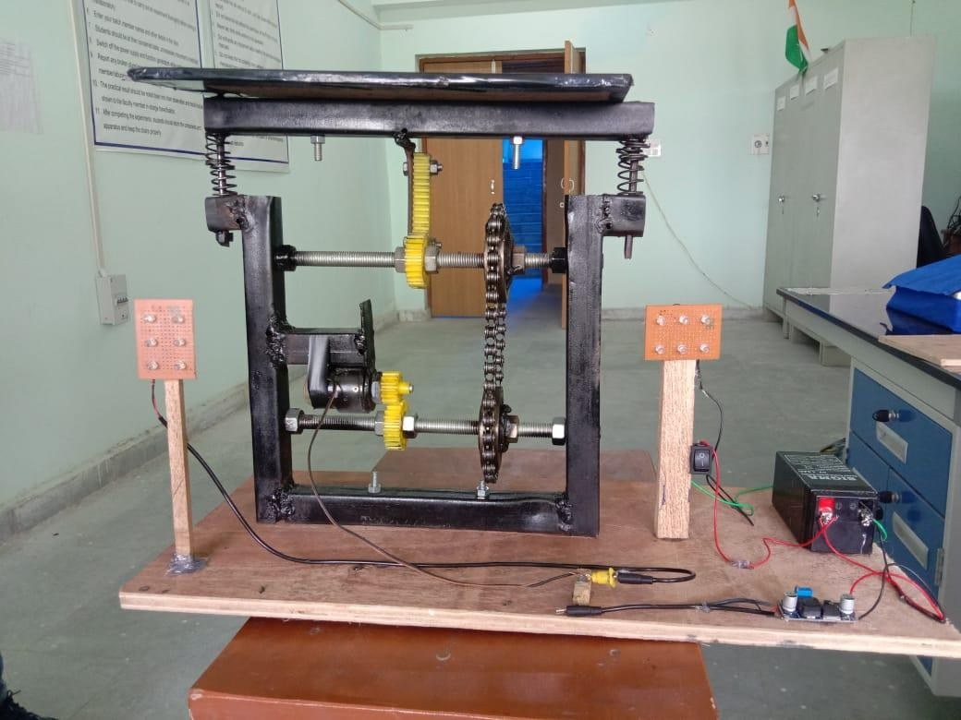1:5 speed ratios. As the shaft of DC generator rotates, it produces electricity. This electricity is stored in a battery. Then the output of the battery is used to lighten the street lamps on the road. Now during daytime, we don’t need electricity for lightening the street lamps so we are using a control switch which is manually operated. The control switch is connected by wire to the output of the battery. The control switch as ON/OFF mechanism which allows the current to flow when needed.

Fig.1.Electrical power generation using speed break

**CHAPTER 2**

## LITERATURE REVIEW OF THE PROJECT

An amateur innovator in Guwahati has developed a simple contraption that can generate power when a vehicle passes over a speed breaker. Anagogic, a small-time businessman, has developed a mechanism to generate power by converting the potential energy generated by a vehicle going up on a speed breaker into kinetic energy. The innovation has caught the eye of the Indian Institute of Technology, Guwahati, which will fund a pilot project to generate electricity from speed-breakers. The idea is basic physics, Gogo has welded five-metre-long metal plates into the speed-breaker instead of the conventional bitumen-and-stone-chip rumble strip. The plates are movable and inclined with the help of a spring-loaded hydraulic system. The fulcrum attached plates are pushed down when a vehicle moves over them and bounce back to original position as it passes.

“When the vehicle moves over the inclined plates, it gains height r3esulting in increase in potential energy, which is wasted in a conventional rumble strip”, Gogoi says. “When the plates come down, they crank a lever fitted to a ratchet-wheel type mechanism. This in turn rotates a geared shaft loaded with recoil springs. The output of this shaft is coupled to a dynamo to convert kinetic energy into electricity,” he explains IIT Guwahati has evaluated the machine and recommended it to the Assam ministry of power for large scale funding. A K Das, a professor at IIT’s design department says it is a ‘very viable proposition’ to harness thousands of megawatts of electricity untapped across the country every day. “A vehicle weighing 1000 kg going up a height of 10 cm on such a rumble strip produces approximately 0.98-kilowatt power. So, one such speed-breaker on a busy highway, where about 100 vehicles pass every minute, about one kilo watt of electricity can be produced every single minute.

**CHAPTER 3**

# COMPONENTS AND ITS WORKING

The fabrication of power ramp consists of different types of parts with different specifications. The components of power ramp used in construction is listed and explained its working below.

## Springs

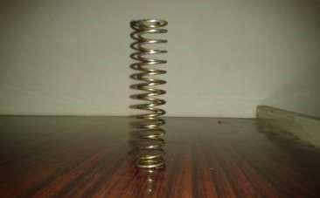

Fig.2. Helical coil spring

A coil spring, also known as a helical spring, is a mechanical device, which is typically used to store energy and subsequently release it, to absorb shock, or to maintain a force between contacting surfaces. They are made of an elastic material formed into the shape of a helix which returns to its natural length when unloaded. Coil spring are a special type of torsion spring: the material of the spring acts in torsion when the spring is compressed or extended. Metal coil springs are made by winding a wire around a shaped former- a cylinder is used to form cylindrical coil springs.

## 0Variants

The two usual types of coil spring are:

1. Tension coil springs, designed to resist stretching. They usually have a hook or eye form at each end for attachment.
2. Compression coil springs, designed to resist being compressed. A typical use for compression coil springs is in car suspension systems.

## Degradation

Many types of coil spring are wound in an annealed (soft) condition and then tempered to achieve their strength as a spring. Over time, this tempering can be lost and the spring will sag because it can no longer withstand the loads applied. Such springs can be reset by annealing, returning to their original length (or deliberately setting them to a different length) and then retempering. Damage to springs, such as using oxy-acetylene to cut the end of a car suspension spring to lower a vehicle’s ride height, can destroy the tempering in localized areas of the spring.

## Rack and Pinion definition

A rack and pinion is a type of linear actuator that comprises a pair of gears which convert rotational motion into linear motion. A circular gear called "the pinion" engages teeth on a linear "gear" bar called "the rack"; rotational motion applied to the pinion causes the rack to move, thereby translating the rotational motion of the pinion into the linear motion of the rack.

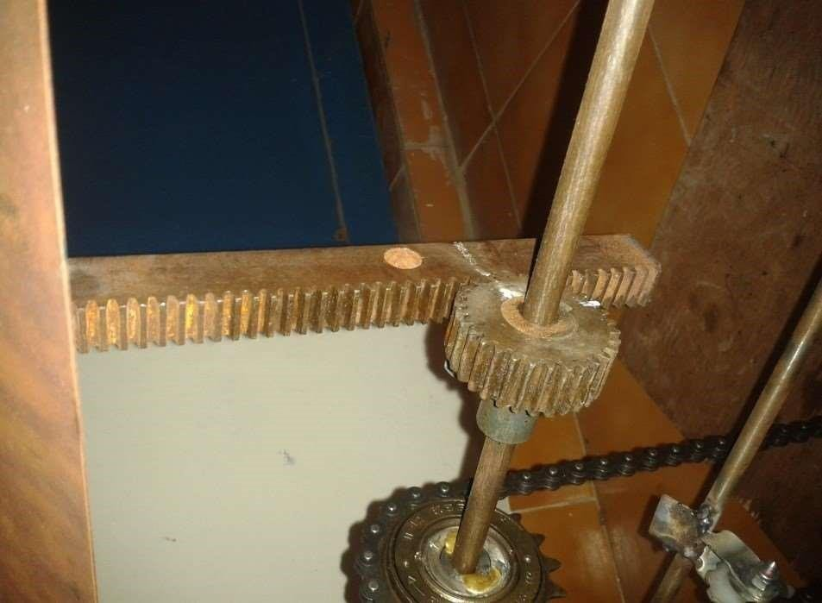



## Belt drive

A belt is a loop of flexible material used to mechanically link two or more rotating shafts. Belts may be used as a source of motion, to transmit power efficiently, or to track relative movement.

Belts are looped over pulleys. In a two pulley system, the belt can either drive the pulleys in the same direction, or the belt may be crossed, so that the direction of the shafts is opposite. As a source of motion, a conveyor lines is one application where the belt is adapted to continuously carry a load between two points.

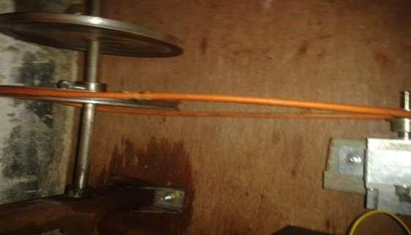

Fig.4. Belt drive

## Sprocket



Fig.5. Sprocket

A sprocket or sprocket-wheel is a profiled wheel with teeth, cogs, or even sprockets that mesh with a chain, track or other perforated or indented material. The name ‘sprocket’ applies generally to any wheel upon which are radial projections that engage a chain passing over it. It is distinguished from a gear in the sprockets are never meshed together directly, and differs from a pulley in that sprockets have teeth and pulleys are smooth. Sprockets are used in bicycles, motorcycles, cars, tracked vehicles, and the other machinery either to transmit rotary motion between two shafts where gears are unsuitable or to impart linear motion to a track, tape etc. perhaps the commonest form of sprocket is found in the bicycle, in which the pedal shaft caries a large sprocket-wheel which drives a chain which in turn drives a small sprocket on the axle of the rear wheel. Early automobiles were also largely driven by sprocket and chain mechanism, a practice largely copied from bicycles.

Sprockets are of various designs; a maximum of efficiency being claimed for each by its originator. Sprockets typically do not have a flange. Some sprockets used with timing belts have flanges to keep the timing bet cantered. Sprockets and chains are also used for power transmission from one shaft to another where slippage is not admissible, sprocket chains being used instead of belts or ropes and sprocket-wheels instead of pulleys. They can be run at high speed and some forms of chain are so constructed as to be noiseless even at high speed.

## Transportation

In the case of bicycle chains, it is possible to modify the overall gear ratio of the chain drive by varying the diameter (and therefore, the tooth count) of the sprockets on each side of the chain. This is the basis of derailleur gears. A 10-speed bicycle, by providing two different-sized driving sprockets and five different-sized driven sprockets, allows up to ten different gear ratios. The resulting lower gear ratios make the bike easier to pedal up hills while the higher gear ratios make the bike faster to pedal on flat roads. In a similar way, manually changing the sprockets on a motorcycle can change the characteristics of acceleration and top speed by modifying the final drive gear ratio.

## Tracker vehicles

A bi-cycle chain is a roller chain that transfers power from the pedals to the drive-wheel of a bicycle, thus propelling it. Most bicycle chains are made from plain carbon or alloy steel, but some are nickel to prevent rust, or simply for aesthetics. Nickel also confers a measure of self- lubrication to a chain’s moving parts. Nickel is a relatively non-galling metal.

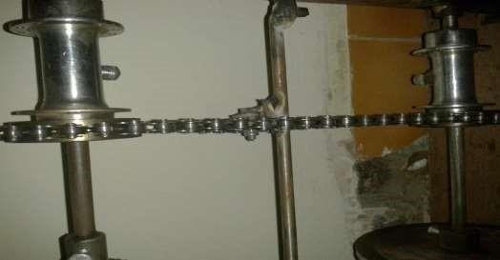

Fig.6. Chain drive

## Efficiency

A bicycle chain can be very energy efficient: one study reported efficiencies as high as 98.6%. The study, performed in a clean laboratory environment, found that efficiency was not greatly affected by the state of lubrication. A larger sprocket will give a more efficient drive, reducing the movement angle of the links. Higher chain tension was found to be more efficient:

“This is actually not in the direction you’d expect, based simply on friction”.

## Maintenance

How best to lubricate a bicycle chain is a commonly debated question among cyclists. Liquid lubricants penetrate to the inside of the links and are not easily displaced, but quickly attract dirt. “Dry” lubricants, often containing wax or Teflon, are transported by an evaporating solvent, and stay cleaner in use. The cardinal rule for long chain life is never to lubricate a dirty chain, as this washes abrasive particles into the rollers. Chain should be cleaned before lubrication. The chain should be wiped dry after the lubricant has had enough time to penetrate the links. An alternative approach is to change the (relatively cheap) chain very frequently; then proper care is less important. Some utility bicycles have fully enclosing chain guards which virtually eliminate chain wear and maintenance. On recumbent bicycles the chain is often run through tubes to prevent if from picking up dirt, and to keep the cyclists leg free from oil and dirt.

## Removal

On most upright bicycles, the chain loops through the right rear triangle made by the right chain stay, right seat stay, and seat tube. Thus a chain must be separated: “broken” is a term commonly used, with a chain tool or at a master link. A master link, also known as a connecting links, allows the chain to be inserted or removed with simpler tools, or even no tools, for cleaning or replacement.

## Wear

Chain wear, or chain stretch, becomes an issue with extensive cycling. Although the overall effect is often called “stretch”, chains generally wear through attrition of the bushings (or half bushings, in the sides design) and not by elongation of the side plates. Then tension created by pedalling is insufficient to cause the latter. Because an old chain is longer than needed, its links will not precisely fit the spaces between teeth in the drive train, making gear shifts a problem and possibly resulting in a ‘skipping’ chain that reduces power transfer and makes pedalling very uncomfortable.

Since chain wear is strongly aggravated by dirt getting into the links, the lifetime of a chain depends mostly on how well it is cleaned (and lubricated) and does not depend on the mechanical load. Therefore, well-groomed chains of heavily used racing bicycles will often last much longer than those of a lightly used, but not so well cleaned city bike. Depending on use and cleaning, a chain can last only 1000 km (e.g. in cross-country use, or all-weather abuse), 3000 to 5000 km for well-maintained derailed chains, or more than 6000 km for perfectly groomed high quality chains, single-gear, or hub- gear chains (preferably with a full cover chain guard).

Chain wear rates are highly variable, so replacement by calendar is likely to cause either needless chain replacement or continued use of a worn chain, damaging rear sprockets. One way to measure wear is with a ruler. Another is with a chain wear tool, which typically has a “tooth” of about the same size found on a sprocket. They are simply placed on a chain under light load and report a “go/no- go” result- if the tooth drops in all the way, the chain should be replaced.

Twenty half-links in a new chain measure 10” (256mm), and replacement is recommended before the old chain measures 256 mm (0.7% wear). A safer time to replace a chain is when 24 half-links in the old chain measure 12 1/16 inches (0.5% wear). If the chain has worn beyond this limit, the rear sprockets are also likely to wear, in extreme cases followed by the front chain rings. In this case, the ‘skipping’ mentioned above is liable to continue even after the chain is replaced, as the teeth of the sprockets will have become unevenly worn (in extreme cases, hook shaped). Replacing worn sprocket cassettes and chain rings after missing the chain replacement window is much more expensive than simply replacing a worn chain in the first place.

## Size

## The chain in use on modern bicycles has a 1/2” pitch, which is ANSI standard 40, where the 4 indicates the pitch of the chain in eighths of an inch, and metric 8, where the 8 indicates the pitch in sixteenth of an inch.

## Width

Chains come in 3/32”, 5/32” or 3/16” roller widths. 5/32” is used on cargo bikes and tiers. 1/8” with coaster brake (back pedal) bikes, hub gear and fixed available in the smaller 3/32” widths; fixed gear and single-speed bikes can be set up to use either 1/8” or 3/32” chains. 3/32” chains are narrower

and lighter, desirable qualities to ease shifting on a derailleur-equipped bicycle but not useful on a single-speed bicycle. This type of chain and crank would only be used for economy on a single-speed. Finally, Derailleur equipped bikes such as racing; touring and mountain bikes use 3/32” chains exclusively.

The “Bicycle Maintenance and Repair”, explains that the difference between derailleur chains commonly labelled 8-speed , 9-speed, and 10-speed is in its external width(all are 3/32” chains, that is, in their minimum internal clearances).

## Length

New chains usually come in a stock length, long enough for most upright bike applications. The appropriate number of links must be removed before installation in order for the drive train to function properly. The pin connecting links can be pushed out with a chain tool to shorten, and additional links may be added to lengthen.

In the case of derailleur gears the chain is usually long enough so that it can be shifted onto the largest front chain ring and the largest rear sprocket without jamming, and not so long that, when shifted onto the smallest front chain ring and the smallest rear sprocket, the rear derailleur cannot take up all the slack. Meeting both these requirements is only possible if the rear derailleur is compatible with the gear range being used on the bike.

In the case of single-speed bicycles and hub gears, the chain length must match the distance between crank and rear hub and the sizes of the front chain ring and rear sprocket. These bikes usually have some mechanism for small adjustments such as horizontal dropouts, track ends, or an eccentric mechanism in the rear hub or the bottom bracket. In extreme cases, a chain half-link may be necessary.

## 3.5.3.4 Variants

In order to reduce weight, chains have been manufactured with hollow pins and with cut-outs in the links. A few titanium chains have also been made, but while much lighter they are vastly more expensive, perhaps 10x the cost, and the titanium bearing surfaces reportedly wear quickly, leading to shortened life and reduced efficiency.

## Dynamo

A dynamo, originally another name for an electrical generator, generally means a generator that produces direct current with the use of a commutator. Dynamos were the first electrical generators capable of delivering power for industry, and the foundation upon which many other later electric- power conversion devices were based, including the electric motor, the alternating current alternator, and the rotary converter. Today, the simpler alternator dominates large scale power generation, for efficiency, reliability and cost reasons. A dynamo has the disadvantages of a mechanical commutator.

Also, converting alternating to direct current using power rectification devices (hollow state or more recently solid-state) is effective and usually economic. The word still has some regional usage as a replacement for the word generator. A small electrical generator built into the hub of a bicycle wheel to power lights.

## Description

The dynamo uses rotating coils of wire and magnetic fields to convert mechanical rotation into a pulsing direct electric current through Faraday’s law of induction. A dynamo machine consists of a stationary structure, called the stator, which provides a constant magnetic field, and a set of rotating windings called the armature which turn within that field. The motion of the wire within the magnetic field causes the field to push on the electrons in the metal, creating an electric current in the wire. On small machines the constant magnetic field may be provided by one or more permanent magnets; larger machines have the constant magnetic field provided by one or more electromagnets, which are usually called field coils. The commutator was needed to produce direct current. When a loop of wire rotates in a magnetic field, the potential induced in it reverses with each half turn, generating an alternating current. However, in the early days of electric experimentation, alternating current generally had no known use. The few uses for electricity, such as electroplating, used direct current provided by messy liquid batteries. os were invented as a replacement for batteries. The commutator is essentially a rotary switch. It consists of a set of contacts mounted on the machine’s shaft, combined with graphite-block stationary contacts, called “brushes”, because the earliest such fixed contacts were metal brushes. The commutator reverses the connection of the winding to the external circuit when the potential reverses, so instead of alternating current, a pulsing direct current is produced.

## Dynamo as Dc generator

After the discovery of the AC generator and that alternating current can in fact be useful for something, the word dynamo became associated exclusively with the commutated DC electric generator, while an AC electrical generator using either slip rings or rotor magnets would become known as an alternator.

An AC electric motor using either slip rings or rotor magnet was referred to as a synchronous motor, and commutated DC motor could also be called an electric motor though with the understanding that it could in principle operate as a generator.

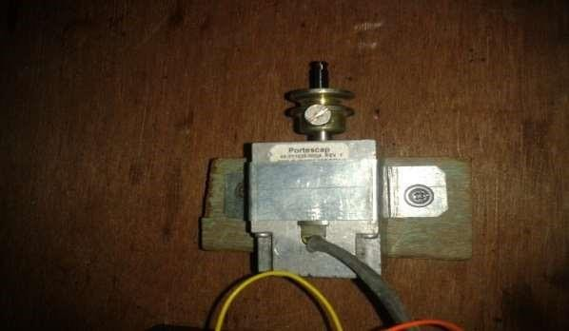

Fig.7. PMDC motor

## Rotary converter development

After dynamos and motors were found to allow easy conversion back and forth between mechanical or electrical power, they were combined in devices called rotary converters, rotating machines whose purpose was not to provide mechanical power to loads but to convert one type of electric current into another, for example DC into AC. They were multi-field single-rotor devices with two or more sets of rotating contacts (either commutator or slip rings, as required), one to provide power to one set of armature winding to turn the devices, and one or more attached to other windings to produce the output current.

The rotary converter can directly convert, internally, any type of electric power into any other. This includes converting between direct current (DC) and alternating current (AC), three phase and single phase power, 25 Hz AC and 60 Hz AC, or many different output voltages at the same time. This size and mass of the rotor was made large so that the rotor would act as a flywheel to help smooth out any sudden surges or dropouts in the applied power.

The technology of rotary converters was replaced in the early 20th century by mercuryvapor rectifiers, which were smaller, did not produce vibration and noise, and required less maintenance. The same conversion tasks are now performed by solid state power semiconductor devices. Rotary converters were still used for the West Side IRT subway in Manhattan into the late 1960’s and possibly some years later. They were powered by 25 Hz AC, and provided DC at 600 volts for the trains.

## Modern uses

Dynamos still have some uses in low power applications, particularly where low voltage DC is required, since an alternator with a semiconductor rectifier can be inefficient in these applications.

Hand cranked dynamos are used in clockwork radios, hand powered flashlights, mobile phone rechargers, and other human powered equipment to recharge batteries.

## Battery

Lead-acid batteries, invented in 1859 by French physicist Gaston planet, are the oldest type of rechargeable battery. Despite having a very low energy-to-weight ratio and a low energytovolume ratio, their ability to supply high surge currents means that the cells maintain a relatively large power

–to-weight ratio. These features, along with their low cost, make them attractive for use in motor vehicles to provide the high current required by automobile starter motors.

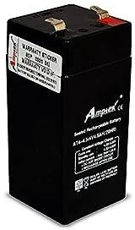

Fig.8. Battery

## CYCLES

* + - 1. **Starting batteries**

Lead acid batteries designed for starting automotive engines are not designed for deep discharge. They have a large number of thin plates designed for maximum surface area, and therefore maximum current output, but which can easily be damaged by deep discharge. Repeated deep discharges will result in capacity loss and ultimately in premature failure, as the electrodes disintegrate due to mechanical stresses that arise from cycling. Starting batteries kept on continuous float charge will have corrosion in the electrodes disintegrate due to mechanical stresses that arise from cycling. Starting batteries kept on continuous float charge will have corrosion in the electrodes and result in premature failure. Starting batteries should be kept open circuit but charged regularly (at least once every two weeks) to prevent sulfation.

Starting batteries are lighter weight than deep cycle batteries of the same battery dimensions, because the cell plates do not extend all the way to the bottom of the battery case. This allows loose disintegrated lead to fall off the plates and collect under the cells, to prolong the service life of the battery. If this loose debris rises high enough it can touch the plates and lead to failure of a cell, resulting in loss of battery voltage and capacity.

## LED light

LED (Light-Emitting Diode) lights are a type of lighting technology that uses semiconductor diodes to produce light. LEDs have gained popularity in recent years due to their energy efficiency, longevity, and versatility. Here are some key features and uses of LED lights:

LED lights are highly energy-efficient compared to traditional incandescent or fluorescent lights. They consume significantly less electricity while producing the same or even brighter light output.

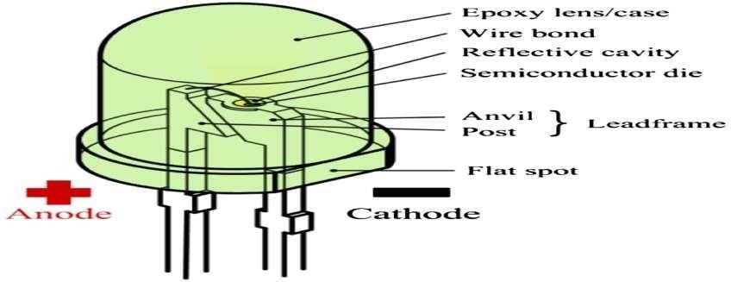

Fig.9. LED light

## 3.8.1.1 Lifetime and failure

Solid state devices such as LEDs are subject to vary limited wear and tear if operated at low currents and at low temperatures. Many of the LEDs made in the 1970s and 1980s are still in service today. Typical lifetimes quoted are 25000 to 100000 hours, but heat and current settings can extend or shorten this time significantly. The most common symptom of LED (and diode laser) failure is the gradual lowering of light output and loss of efficiency. Sudden failures, although rare, can occur as well. Early red LEDs the devices are subjected to higher junction temperatures and higher current densities than traditional devices. This causes stress on the material and may cause early light-output degradation. To quantitatively classify lifetime in a standardized manner it has been suggested to use the terms L75 and L50, which is the time it will take a given LED to reach 75% and 50% light output respectively.

Like other lighting devices, LED performance is temperature dependent. Most manufacturers published ratings of LEDs are for an operating temperature of 25◦C. LEDs used outdoors, such as traffic signals or in pavements signal lights, and that are utilized in climates where the temperature within the luminaire gets very hot, could result in low signal intensities or even failure.

LED light output rises at lower temperatures, levelling off depending on type at around 30◦C. Thus, LED technology may be a good replacement in uses such as supermarket freezer lighting and will last longer than other technologies. Because LEDAs emit less heat than incandescent bulbs, they are an energy-efficient technology for users such as freezers. However, because they emit little heat, ice and snow may build up on the LED luminaire in colder climates.

**CHAPTER 4**

# DYNAMO AS DC MOTOR

A DC motor is an electric motor that runs on direct current (Dc) electricity. DC motors were used to run machinery, often eliminating the need for a local steam engine or internal combustion engine. DC motors can operate directly from rechargeable batteries, providing the motive power for the first electric vehicles. Today DC motors are still found in applications as small as toys and disk drives, or in large sizes to operate steel rolling mills and paper machines.

Modern DC motors are nearly always operated in conjunction with power electronic devices.

## Brushed

This is a brushed DC electric motor generating torque directly from DC power supplied to the motor by using internal commutation, stationary permanent magnets. Torque is produced by the principle of Lorentz force, which states that any current-carrying conductor placed within an external magnetic field experiences a force known as Lorentz force. The commutator consists of a split ring 80 degree shows the effects of having a split ring. The brushed DC electric motor generates torque directly from DC power supplied to the motor by using internal commutation, stationary magnets(permanent of electromagnets), and rotating electrical magnets. Like all electric motors or generators, torque is produced by the principle of Lorentz force, which states that any current-carrying conductor placed within an external magnetic field experiences a torque or force known as Lorentz force. Advantages of a brushed DC motor include low initial cost, high reliability, and simple control of motor speed. Disadvantages are high maintenance and low life-span for high intensity uses. Maintenance involves regularly replacing the brushes and springs which carry the electric current, as well as cleaning or replacing the commutator. These components are necessary for transferring electrical power from outside the motor to the spinning wire windings of the rotor inside the motor

## Brushless

DC motors use a rotating permanent magnet or soft magnetic core in the rotor, and stationary electrical magnets on the motor housing. A motor controller converts DC to AC. This design is simpler than that of brushed motors because it eliminates the complication of transferring power from outside the motor to the spinning rotor. Advantages although they have no external power supply to be synchronized with, as would be the case with normal AC synchronous motors.

## Connection types

There are three types of connections used for DC electric motors: series, shunt and compound. These types of connections configure how the motor’s field and armature windings are connected together. The type of connection is significant because it determines the characteristics of the motor and is selected for speed/torque requirements of the load.

## Series connection

A series DC motor connects the armature and field winding in series with a common D.C. power source. This motor has poor speed regulation since its speed varies approximately inversely to load. However, a series DC motor has very high starting torque and is commonly used for starting high inertia loads, such as trains, elevators or hoists. With no mechanical load on the series motor, the current is low, the magnetic field produced by the field winding is weak, and so the armature must turn faster to produce sufficient counter-EMF to balance the supply voltage (and internal voltage drops). For some types of motor , the speed may be higher than can be safely sustained by the motor. In a no-load condition, the motor may increase its speed until the motor mechanically destroys itself. This is called a runaway condition. The speed/torque characteristic is also useful in application such as dragline excavators, where the digging tool moves rapidly when unloaded but slowly.

Series motors called “universal motors” can be used on alternating current. Since the armature voltage and the field direction reverse at (substantially) the same time, torque continues to be produced in the same direction. Since the speed is not related to the line frequency, universal motors can develop higher-than-synchronous speeds, making them lighter than induction motors of the same rated mechanical output. This is a valuable characteristic for hand-held power tools. Universal motors for commercial power frequency are usually small, not more than about 1 KW output. However, much larger universal motors were used, fed by special low-frequency traction power networks to avoid problems with commutation under heavy and varying loads.

## Shunt connection

A shunt DC motor connects the armature and field winding in parallel or shunt with a common DC power source. This type of motor has good speed regulation even as the load varies, but does not have as high of starting torque as a series DC motor. It is typically used for industrial,

adjustable speed applications, such as machine tools, winding/unwinding machines and tensioners.

## MOTOR BASIC PRINCIPLES

* + 1. **Energy conversion**

As stated above, mechanical energy is changed into electrical energy by movement of conductor through a magnetic field. The converse of this is also true. If electrical energy is supplied to a conductor lying normal to a magnetic field, resulting in current flow in the conductor, a mechanical force and thus mechanical energy will be produced.

## Producing mechanical force

As in the generator, the motor has a definite relationship between the direction of the magnetic flux, the direction of motion of the conductor or force, and the direction of the applied voltage or

current. Since the motor is the reverse of the generator, Fleming’s left hand rule can be used. If the thumb and first two fingers of the left hand are extended at right angles to one another, the thumb will indicate the direction of motion, he forefinger will indicate the direction of the magnetic field, and middle finger will indicate the direction of current. In either the motor or generator, if the directions of any two factors are known, the third can be easily determined.

## Value of mechanical force

The force exerted upon a current carrying conductor is dependent upon the density of the magnetic field, the length of conductor, and the value of current flowing in the conductor.

Assuming that the conductor is located at right angles to the magnetic field, the fore developed can be expressed as follows

# F = B l

Where:

F= force in dynes

B= flux density in lines per square centimetre l= length of the conductor in centimetre

At the same time torque is being produced, the conductors are moving in a magnetic field and generating a voltage. This voltage is in opposition to the voltage that causes current flow through the conductor and is referred to as a counter voltage or back EMF. The value of current flowing through the armature is dependent upon the difference between the applied voltage and the counter voltage.

Sample Calculations Generator

Given:

N = 60 turns

B = 40,000 lines per square inch l*= 3.0 inches V= 600 inches per second Find: E = voltage

E = 60 x 40,000 x 3 x 600 x 10-8 = 43.2 volts

Motor Given:

B = 6000 lines per square centimetre L = 10 Centimetres Find:

F = force

F = (6000 x 10 x 50)/ 10 = 3,00,000 dynes

Newton’s = pounds x 4.44823 Dynes = Newton’s x 1,00,000

**CHAPTER 5**

# WORKING PRINCIPLE

The project is concerned with generation of electricity from speed breakers-like set up. The load acted upon the speed breaker-setup is there by transmitted to roller chain arrangements. Here the reciprocating motion of the speed-breaker is converted into rotary motion using the roller chain arrangement. The axis of the pinion is coupled with the sprocket arrangement. The sprocket arrangement is made of two sprockets. One is of the larger size and the other is smaller size. Both the sprockets are connected by means of a chain which serves in transmitting power from the larger sprocket to the smaller sprocket? As the power is transmitted from the larger sprocket to the smaller sprocket, the speed that is available at the larger sprocket is relatively multiplied at the rotation of the smaller sprocket.

The axis of the smaller sprocket is coupled to a chain arrangement. Here we have roller chain with suitable diameters. The roller chain with the larger dimension is coupled to the axis of the smaller sprocket. Hence the speed that has been multiplied at the smaller sprocket wheel is passed on to this roller chain of larger dimension. The smaller sprocket is coupled to the larger sprocket. So as the larger gear rotates at the multiplied speed of the smaller sprocket, the smaller gear following the larger gear still multiplies the speed to more intensity. Hence, although the speed due to the rotary motion achieved at the larger sprocket wheel is less, as the power is transmitted to gears, finally the speed is multiplied to a higher speed. This speed which is sufficient to rotate the rotor of a generator is fed into the rotor of a generator. The rotor which rotates within a static magnetic stator cuts the magnetic flux surrounding it, thus producing the electric motive force (emf). This generated emf is then sent to an inverter where the generated emf is regulated. This regulated emf is now sent to the storage battery where it is stored during the day time. This current is then utilized in the night time for lighting purposes on the either sides of the road to a considerable distance.

The kinetic energy of moving vehicles can be converted into mechanical energy of the shaft through roller chain mechanism. This shaft is connected to the electric dynamo and it produces electrical energy proportional to traffic density. This generated power can be regulated by using zener diode for continuous supply. All this mechanism can be housed under the dome like speed breaker, which is called ramp. The generated power can be used for general purpose like streetlights, traffic signals. The electrical output can be improved by arranging these power ramps in series this generated power can be amplified and stored by using different electric devices. The maintenance cost of ramp is almost nullified. By adopting this arrangement, we can satisfy the future demands to some extent.

Whenever the vehicle is allowed to pass over the dome it gets pressed downwards then the springs are attached to the dome is compressed and the chain which is attached to the bottom of the dome moves downward in reciprocating motion. Since the chain is connected to sprockets, there exists

conversion of reciprocating motion of chain into rotary motion of sprockets but the two sprockets rotate in opposite direction. So that the sprocket will rotate with certain R.P.M these sprocket is connected through a belt drive to the dynamos, which converts the mechanical energy into electrical energy. The conversion will be proportional to traffic density.

Whenever an armature rotates between the magnetic fields of south and north poles, an emf (electro motive force) is induced in it. So, for inducing the emf armature coil has to rotate, for this rotation kinetic energy of moving vehicles is utilized. The power is generated in both the directions; to convert this power into one Way a special component is used called zener diode for continuous supply. All this mechanism can be housed under the dome, like the prime mover turns. The rotor contains a magnet that, when turned, produces a moving or rotating magnetic field. The rotor is surrounded by a stationary casing called the stator, which contains the wound copper coils or windings. When the moving magnetic field passes by these windings, electricity is produced in them. By controlling the speed at which the rotor is turned, a steady flow of electricity is produced in the windings.

Electricity from a speed breaker first of all what is electricity means to us? Electricity is the form of energy. It is the flow of electrical power. Electricity is a basic part of nature and it is one of our most widely used forms of energy. We get electricity, which is a secondary energy source, from the conversion of other natural sources, which are called primary sources. Many cities and towns were built alongside waterfalls that turned water wheels to perform work.

Before electricity generation began slightly over 100 years ago, houses were lit with kerosene lamps, food was cooled in iceboxes, and rooms were warmed by wood-burning or coal-burning stoves. Direct current (DC) electricity had been used in arc lights for outdoor lighting. In the late1800s, Nikola Tesla pioneered the generation. Transmission and use of alternating current (AC) electricity, which can be transmitted over much greater distances than direct current. Tesla’s inventions used electricity to bring indoor lighting to our homes and to power industrial machines. How is electricity generated? Electricity generation was first developed in the 1800’s using Faradays dynamo generator. Almost 200 years later we are still using the same basic principles to generate electricity only on a much larger scale.



Fig.10. Complete setup

## MATERIALS USED

The various machine elements used in the construction of power hump are

1. Return spring
2. Rack
3. Pinion
4. Ball bearing
5. Sprocket
6. Chain drive
7. Gear wheel
8. PMDC generator
9. Battery
10. Shaft

A dome is mounted on four springs and in the bottom, a rack is clamped. The rack consists of contact teeth on both the faces. It is connected to two gear wheels to rotate the gear wheels only in one direction. We have inserted a free wheel in each gear. The free wheel and the gear assembly are mounted centrally. The flywheel is also mounted on the same shaft and the shaft is simply supported at eh both ends by means of ball bearings. Now a dynamo is connected to each shaft by belt drive. The output terminal of dynamo is connected to an electrical storing device.

## LIST OF MATERIALS

|  |  |  |  |
| --- | --- | --- | --- |
| S.NO | NAME OF THE PRODUCT | **MATERIAL USED** | **QUANTITY** |
| 1. | Base frame | Mild steel | 1 |
| 2. | Roller chain | Cast iron | 1 |
| 3. | Ramp | Mild steel | 1 |
| 4. | Springs | Alloy steel | 4 |
| 5. | Sprockets | Brass | 2 |
| 6. | Electric dynamo | -------------- | 1 |
| 7. | Battery | Lead acid | 1 |
| 8. | Light | LED | 1 |
| 9. | Bolt & nut | Brass | 1 |
| 10. | Pole coupler | Aluminium | 1 |

**CHAPTER 6 CALCULATIONS**

# Spring design

The height of spring is 0.3 m before loading .the deflection of the spring by δ =64 w*n*N*R^3/(Gd^4)

Where,

Free length of spring =150 mm Mean diameter (D) = 15 mm Wire diameter (d) = 1 mm

Weight of body = 15 kg (min load)

Modulus of rigidity = 8*10^4 N/mm^2

δ = 8*w*D^3*n/(G*d^4)

= 8*15*9.81*15/(8*10^4*1)

= 0.220755 mm

δ = Deflection(in our case maximum δ = 0.220725 mm) W = designed load (min load =15kg & max load 25 kg)

R = mean diameter of coil (15 mm) D = diameter of wire (1 mm)

N = no of spring turns (25 turns)

G = Modulus of rigidity = 8*10^4 N/MM² N = No. of springs (2)

Determining the number of teeth for the driver sprocket Chain speed: v= do.n/19100 (m/s)

Where:

do = sprocket reference diameter in mm

n = sprocket revolution (r.p.m) v = chain velocity (m/s) 19,100 = constant

## OUTPUT POWER CALCULATION

The mass of a body moving over the speed breaker = 15 Kg (approximately)

Height of speed breaker = 150 mm

Work done = Force X Distance.

Here,

Force= weight of the Body

= 15 Kg x 9.81 F = 147.15 N

Distance travelled by the body= height of the speed breaker= 150 mm

Output power = work done/sec

= (147.15 x 0.015)/60

P = 2.20725 Watts (For one pushing force) Power developed for 1 body passing over the speed

Breaker arrangement for one minute = 2.20725 watts Power developed for 60 minutes (1 hr) = 132.435 watts

Power developed for 24 hours 3.17844 Kw

This power is sufficient to burn four street lights in the roads in the night time.

## MERITS AND DEMERITS

**Merits**

* 1. Low budget electricity production, since the setup has simple parts such as chains sprockets and springs.
  2. As the construction type is concerned that there is no damage to vehicles and no obstruction of traffic.
  3. It is easily maintained by painting the setup by anti rusting paint and oiling it frequently so total maintenance charge is less.
  4. It is suitable at parking of multiplexes, malls, toll booths, signals etc. since it takes more time to move a certain distance, therefore when the power ramp is fixed in a crowd area so power can be generated.
  5. Uses: charging batteries and using them to light up the streets, etc.
  6. The power is fixed firmly to the ground and the construction is designed by the exact dimensions required therefore less floor area can be used.

## Demerits

1. Since the power consumption depends upon the transmission of vehicles each selection of springs, such that it should withstand the weight of the vehicle.
2. Achieving proper balance of speed and torque.
3. It gives low electric output.

**COST ESTIMATION**

|  |  |  |  |
| --- | --- | --- | --- |
| **S.NO** | **NAME OF THE**  **PRODUCT** | **QUANTITY** | **COST (Rs)** |
| 1. | Metal frame | 1 | 300 |
| 2. | Bearing | 1 | 200 |
| 3. | PMDC motor | 1 | 150 |
| 4. | Sprockets | 2 | 300 |
| 5. | Rack and  Pinion | 1 | 100 |
| 6. | Battery | 1 | 500 |
| 7. | Wiring | 2 | 100 |
| 8. | Bolt nut | 1 | 50 |
| 9. | Spring | 4 | 300 |
| 10. | Chain | 1 | 100 |
| 11. | Welding  charges | ---- | 200 |
| 12. | Rod and sheet material | 3 | 600 |
|  | Total cost |  | 2,900 |

**CHAPTER 7**

# CONCLUSION

Energy is an important input to sustain industrial growth and standard of living of a country and can be directly related to per-capita energy consumption. The conventional sources energy like coal, oil, uranium etc.. are depleting very fast and by the turn of the century man will have to depend upon non-conventional sources of energy for power generation.

1. The various types of non-conventional sources of energy are solar energy, wind energy, biogas etc… now by developing “Power ramp” we can generate power without utilizing any external sources mentioned earlier.
2. Vehicular traffic in big cities is more, causing a problem to human being. But this vehicular traffic can also be utilized for power generation by means of new technique called “Power ramp”. If it is placed in heavy traffic roads, the weight and kinetic energy of the vehicles can be used to produce mechanical power in shafts and this mechanical power is once again converted into electrical energy.
3. The major drawback of this Power ramp is design of springs. When we have less traffic and there is difficulty in design of springs also the generation of power is intermittent, we have to smooth out this variations.

# RESULTS AND DISCUSSIONS

Hereby we have experimented and pragmatically proved how energy can be tapped and used at a commonly used system like the speed breaker in roads. The number of vehicles passing over the speed breaker in roads is increasing day by day. A large amount of energy is wasted at the speed breakers through the dissipation of heat and also through friction, every time a vehicle

passes over it. There is great possibility of tapping this energy and generating power by making the speed-breaker as a power generation unit. The generated power can be used for the lamps, near the speed breakers.

An energy crisis is any great bottleneck (or price rise) in the supply of energy resources to an economy. An energy crisis may be referred to as an oil crisis, petroleum crisis, energy shortage, electricity shortage electricity crisis. Our project emphasized on creating a renewable source of energy using speed breaker. One might conclude that to be materially rich and prosperous, a human being needs to consume more and more energy. And this project is best source of energy that we get in day to day life.

**REFERENCES**

* 1. Mukherjee.DChakrabarti.S, 2005 , Fundamentals of renewable Energy systems, New Age
  2. international limited publishers, New Delhi.
  3. Sharma.P.C, 2003 , Non-conventional power plants, Public printing Service, NewDelhi.

3. Principles of renewable energy systems, Sharma P.C. 2003.

. 4. Non-conventional power plants Mukherjee.DChakrabarti.S, 2005

1. Fundamentals of renewable energy systems, New Age international limited publishers,

New Delhi.

1. Non-conventional power engineering, public printing service, New Delhi..7‘Power

Publications

1. power System Dynamics and Control’, K R Padiyar, Interline publishers, Bangalore.
2. Power System Stabilizers’ by Mitsubishi Corporation-A release notes From Mitsubishi Co
3. <https://en.wikipedia.org/wiki/Electricity_generation>